

Republic of the Philippines
Department of Education
DIVISION OF QUEZON CITY SCHOOLS
Quezon City

SECOND PERIODICAL TEST
MATHEMATICS IV
SY 2014 – 2015

DIRECTIONS: Write the letter of your choice on your answer sheet. Answers must be in simplest form.

- What is the minimum value of the function f(x) = 2(x + 2)² – 3?
- 2 B. – 2 C. 3 D. – 3
- What is the degree of the polynomial function P(x) = 3x - 9x³ + 5x⁴ – 5 ?
- 3 B. 5 C. 4 D. 9
- Which of the following is a polynomial of three terms ?
- monomial B. multinomial C. binomial D. trinomial
- Find the sum of the roots of the quadratic function f(x) = 5x² + 3x + 7.
- B.- C. D. -
- What is the minimum point of the parabola f(x) = 5x² ‒ 11 ?
- ( 0, 0 ) B. (0, -11) C. (0, 11) D. ( 5, 0)

- Given the polynomial function P(x) = 121x² - 5x¹¹ + x⁸ + 2x⁵ – 50, find its leading term.
- 121x² B. – 5x¹¹ C. x⁸ D. 2x⁵

- What theorem states that “If the polynomial P(x) is divided by (x – c), then the remainder is P (c) ?
- Integral Zero Theorem C. Factor Theorem
- Rational Root Theorem D. Remainder Theorem

- Which of the following defines a polynomial function ?
- P(x) = x⁻ ⁵ + x² + 3x + 6 C. G(x) = 3x³ – 4x + 7
- Q(x) = 3x² + - 2x + 8 D. F(x) = 4 – 11
- The zeros of the polynomial function h(x) = (x – 2) (x + 1) (x – 3) are _____.
- -2 ,1, -3 B. 2, 1, - 3 C. – 2, 1, 3 D. 2, - 1, 3
- The graph of f(x) = x² + 1 is translated 3 units to the left and 1 unit down. What is the equation
of the resulting graph ?
- f(x) = (x – 3)² C. f(x) = (x + 3)² - 1
- f(x) = (x – 3)² - 1 D. f(x) = (x + 3)²
- What is the axis of symmetry of the quadratic function represented by the equation
f(x) = 4(x – 5)² ‒ 2 ?
- x = ‒ 5 B. x = ‒ 4 C. x = 4 D. x = 5
- Which one can not be used to define a polynomial function?
- 4x³+ 3x² + 2x + 1 C. x⁴ + x² + + 3
- x ^{– 4} + x³ + x² + x + 1 D. x³ 4x² + + 7

- How many times does the graph of the function f(x) = (x – 2) (x + 2) (x – 3) cross the x – axis?
- once B. twice C. thrice D. four times

- The polynomial function P(x) = 4x⁴ - 17x² + 4 has how many possible rational zeros?
- 10 B. 6 C. 5 D. 2
15. What is the quotient when 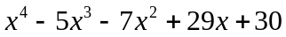 is divided by 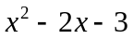?
A. 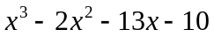 C. 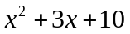
B. 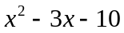 D. 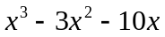
16. Refer to number 15: What is the remainder?
A. 0 B. -10 C. -3 D. x – 3

17. Find the remainder of P(x) = 3x¹⁰⁰ – 4x⁵⁰ + 8 divided by (x + 1).
- 7 B. 8 C. 10 D. 15

18. The square of a number added to 49 equals fourteen times the number. What is the number ?
- 7 B. -7 C. -14 D. 14
19. What is the equation of the parabola :
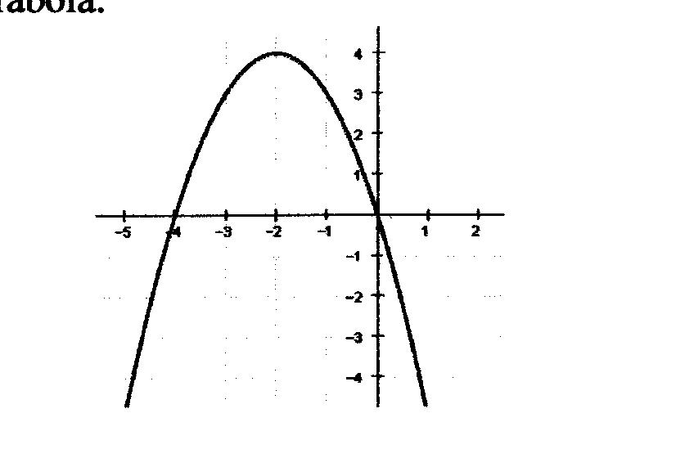
- f(x) = (x + 2)² + 4
- f(x) = (x – 2)² + 4
- f(x) = - (x + 2)² + 4
- f(x) = - (x – 2)² + 4

20. Which of the following synthetic division set up will give the correct quotient of 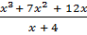 ?
- 3 7 4 1 ∟ 2 C. 1 7 12 0 ∟ -4
- - 1 7 12 4 ∟ 4 D. 1 7 12 1 ∟ -2

21. What is the degree of the depressed expression when a polynomial of degree 4 is divided by x – 4 ?
- 5 B. 2 C. 3 D. 1
22. Find the leading coefficient of the polynomial function f(x) = 3 – 2x² + 5x⁴ + 7x⁶ .
- 6 B. 3 C. 5 D 7
23. The quadratic equation with solution set {± 8} is ____.
- x² + 8x + 64 = 0 C. x² - 16x + 64 = 0
- x² - 64 = 0 D. x² + 16x + 8 = 0
24. What is true about the roots of f(x) = x² - 2x – 8 ?
- The roots are unequal and irrational C. The roots are non-real
- The roots are real and equal D. The roots are unequal and rational

25. What is the value of k if 3x⁴ – 5x³ + kx² + 8 divided by x – 2 yields a remainder of ‒ 16 ?
- 8 B. – 8 C. 3 D. – 3

26. To find the quotient of (5x⁴ + x² - 3x + 10) (x – 2), which of the following solutions of synthetic division will be obtained ?

5 0 1 -3 10 ∟ 2
10 20 42 78
5 10 21 39 88

5 1 -3 10 ∟ 2
10 22 38
5 11 19 48

A. C.

5 0 1 -3 10 ∟ -2
-10 20 -42 -90
5 -10 21 45 -80
5 1 -3 10 ∟ -2
-10 18 -30
5 - 9 15 -20

B. D.

27. If “completing the square” is used to solve x² + 6x – 16 = 0, which of the following equations will
give the roots ?
- (x – 4) ² = 0 B. (x – 4) ² = 16 C. (x + 3) ² = 25 D. x² + 6x = -7
28. Find P(1) if P(x) = x³ - 12x² - 6x + 7.
- -10 B. 10 C. – 11 D. 0
29. Find the range of values of k so that 2x² - 5x + k = 0 has real roots.
- k B. k C. k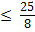 D. k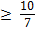

30. What should be the value of kso that (x – 1) is a factor of h (x) = x³ + 5x² - x + k?
- 0 B. – 5 C. 4 D. 5
31. In the given polynomial function P(x) = x³ + x² - 7x – 7, which of the following is the lower bound of its real zeros?
- 0 B. 1 C. 3 D. – 4

32. Find the values of a and b if P(x) = ax³- x² + bx + 1 has a remainder of 15 when divided by (x – 2), given that 1 is a zero of the said polynomial function .
- a = 3 and b = 2 C. a = 3 and b = - 3
- a = - 3 and b = 3 D. a = 2 and b = 3
33. Given 2x² - 5x – 4 = 0. Find its positive root.
A. 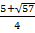 B. 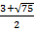 C. 2 D. 4

34. Find the value of k so that the graph of y = x² + 6x + k is above the x – axis.
- 9 B. k 9 C. k 9 D. k = 0
35. Find the value of k so that the equation 2x² - 6x - k = 0 will have two distinct roots.
- k - B. k = - C. k - D. R
For Numbers 36 – 37 refer to the given situation below:
A ball is thrown vertically upward at an initial speed of 128 feet per second. If the distancefrom the ground t seconds after being thrown is y = 128 t – 16 t², neglecting air resistance;
36.Find the maximum height the ball will reach.
- 128 ft. B. 256 ft C. 512 ft. D. 500 ft
37. How long the ball is in the air ?
- 8 seconds B. 6 seconds C. 4 second D. 2 seconds
38. What is the quotient when x⁴ + x³ + 1 is divided by x + 1 ?
A. x² + B.x² + 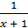 C.x³ + 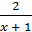 D.x³ +

39. If x + 2 is a factor of x³ – 7x – 6 = 0, what are the other factors?
A. (x + 1)((x – 3) B.(x – 1)(x = 3) C. (x + 3)(x + 1) D. (x + 6)(x – 1)

40. Julia has a rectangular garden with a perimeter of 72 m and an area of 308 m². What is
the length and the width of the garden?

A. length = 77 m B. length = 22 m C. length = 20 m D. length = 32 m
width = 4 m width = 14 m width = 16 m width = 10 m

41. What is the simplified of 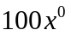?
A. 1 B.0 C. 100 D. 100x
42. If x= 2 and y= -3, what is the value of the expression 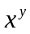?
A. 8 B. 6 C. 1/8 D. -8
43. What are the x-intercepts of f(x) = x² (x +3)(x -2) ?
A. -3 and 2 B. 3 and -2 C. 0, -3 and 2 D. 0, 3 and -2

44. To find the quotient of (2x³ +4x + 12) ÷ (x – 3), which of the following solution of
synthetic division will be obtained?

A. 3˩ 2 0 4 12 C. -3˩ 2 0 4 12
6 18 66 - 6 18 -66
2 6 22 78 2 - 6 22 -54

B. 3˩ 2 4 12 D. -3˩ 2 4 12
6 30 - 6 6
2 10 42 2 -2 8

45. Which of the following will determined if x + 1 is a factor of f(x) = x³ – 15x² + 9x + 5 ?
A. f(x) = (1)³ – 15(1)² + 9(1) + 5 C. f(x) = (1)³ – 15(1)² + 9(1)
B. f(x) = (-1)³ – 15(-1)² + 9(-1) + 5 D. f(x) = (-1)³ – 15(-1)² + 9(-1)
46. What numbers should replace a and b in solving for the roots of x² – 6x – 4 = 0 ?
(x – a)² = b
x – a = A. a = 0, b = 4 C. a = 3, b = 13
x = a B. a = 2, b = 2 D. a = 4, b = 10

47. What is the upper bound for the real zeros of the polynomial function
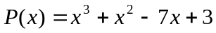
A. 2 B. 3 C. 4 D. 5

48. Which of the following polynomial equation whose zeros are -7, 3 and 4?

A. x³ – 12x² – 7x + 84 = 0 C. x³ – 37x + 84 = 0
B. x³ + 84x² – 14x + 14 = 0 D. x³ + 14x² – 7x + 84 = 0

49. According to Descartes’ rule of signs, how many positive zeros does the polynomial function
f(x) = 4x⁵– 6x³ + 2x² - 6x – 9 ?
A. 3 B. 2 or 0 C. 2 D. 3 or 1

50. What is the range of the function 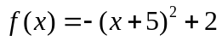 ?
A. 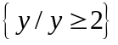 C. 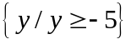
B. 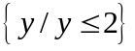 D. 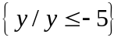

‒ E N D ‒

